**ARINGAR ANNA GOVERNMENT ARTS COLLEGE**

**MUSIRI - 621 211**

**DEPARTMENT OF MATHEMATICS**

**NAAN MUDHALVAN-SMART INTERNZ PROJECT**

PROJECT TITLE: IMPLEMENTING CRM FOR RESULT TRACKING OF A CANDIDATE WITH INTERNAL MARKS.

**SUBMITTED BY**

TEAM LEAD : MATHIVANI .V(CB20S 377331)

TEAM MEMBER 1 : NISHANTHINI. M (CB20S 377333)

TEAM MEMBER 2: SANTHOSH. K (CB20S 377334)

TEAM MEMBER 3: SATHANA. S (CB20S 377335)

INTRODUCTION

HAVE A SUCCESSFUL PROJECT BASED EXPERIENTIAL LEARNING PROGRAM

**r**CRM implementation is the process of [introducing a CRM system](https://nethunt.com/blog/what-is-a-crm/) to your business. It starts from choosing the right solution for your needs, and ends with actively using it to streamline your business processes. However, maybe that’s an overly-simplified account; implementation is a multi-stage process…

1. Identifying a problem that CRM solves
2. [Searching for an appropriate CRM system](https://nethunt.com/blog/how-to-choose-a-crm-system/) for your business
3. Finding appropriate systems and testing it
4. Subscribing or buying the appropriate CRM platform
5. System set up and wider team implementation

The final stage includes migrating all your data, onboarding the team, educating them on the benefits of a CRM solution, customising the system, and adding all the necessary third-party integrations that make the CRM operation as smooth as possible.

1.1:Over view:

**Administrator should be able to create all base data including Semester, Candidate, Course and Lecturer, Lecturer should have the ability to create Internal Results, Dean, who is one of the Lecturer, should be the only one with ability to update Internal Results, Re-evaluation Can be initialized by Candidate for all Internal Results. Now only dean can update the marks after re-evaluation.**

1.2:Purpose:

USE: THIS WILL LET YOU KNOW ABOUT RESULT TRACKING OF A CANDIDATE WITH INTERNAL MARKs.

ACHIEVE: THIS PROJECT FOR RESULT TRACKING OF A CANDIDATE WITH INTERNAL MARKS TO KNOWN .

2. PROBLEM DEFINITION &DESIGN THINKING

2.1: EMPATHY MAP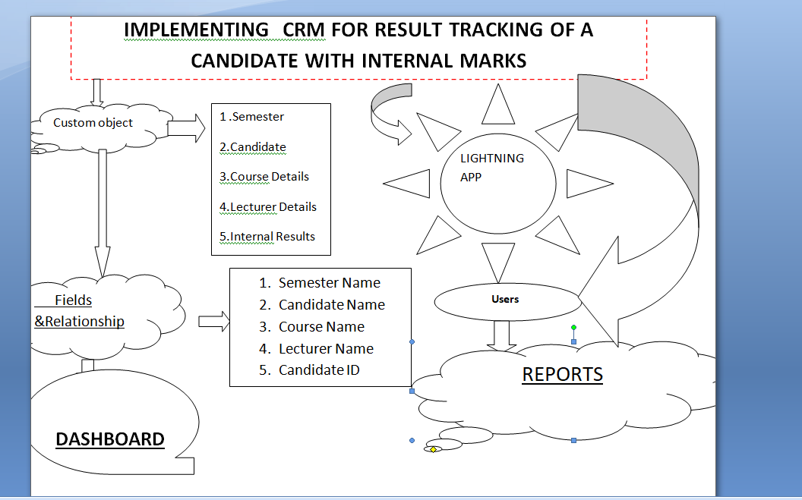  
2.2: IDEATION & BRAINSTROMING MAP

Ad111ovrministrator 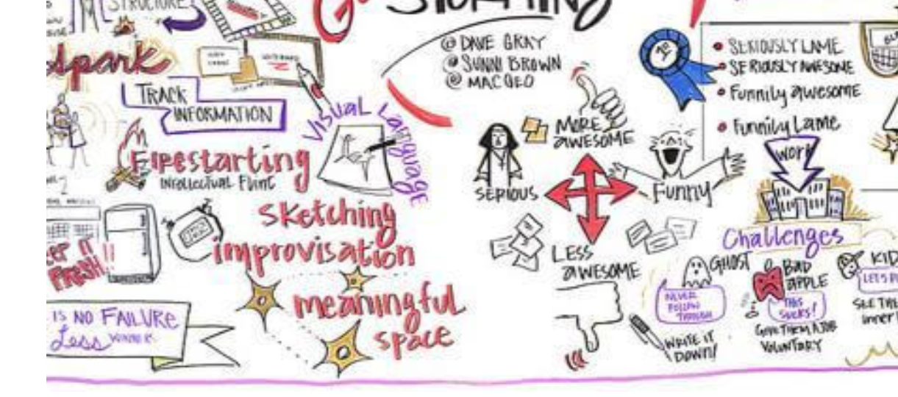should be able to create

3. RESULT:

3.1: DATA MODEL:

|  |  |
| --- | --- |
| Object Name | Fields in the Object |
| Obj 1 | |  |  | | --- | --- | | Field label | Data type | | Semester | Text | | Semesters | Text | |
| Obj2 | |  |  | | --- | --- | | Field label | Data type | | Candidate | Marks | | Candidates | Marks | |

3.2 Activity and Screenshot:

Milestone 1: Creation Salesforce Org.

Activity 1:

Creating a developer org.in salesforce.

Account Activation:

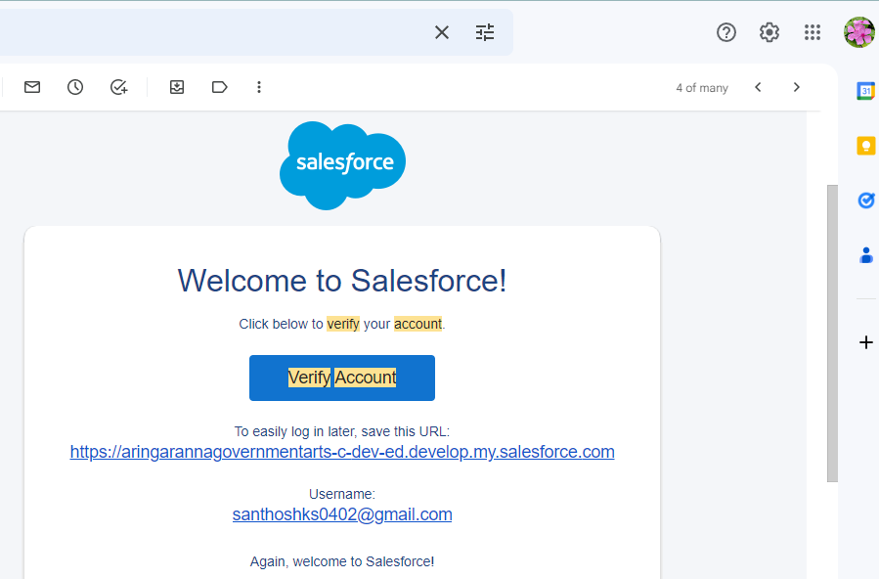

Milestone:2 Object

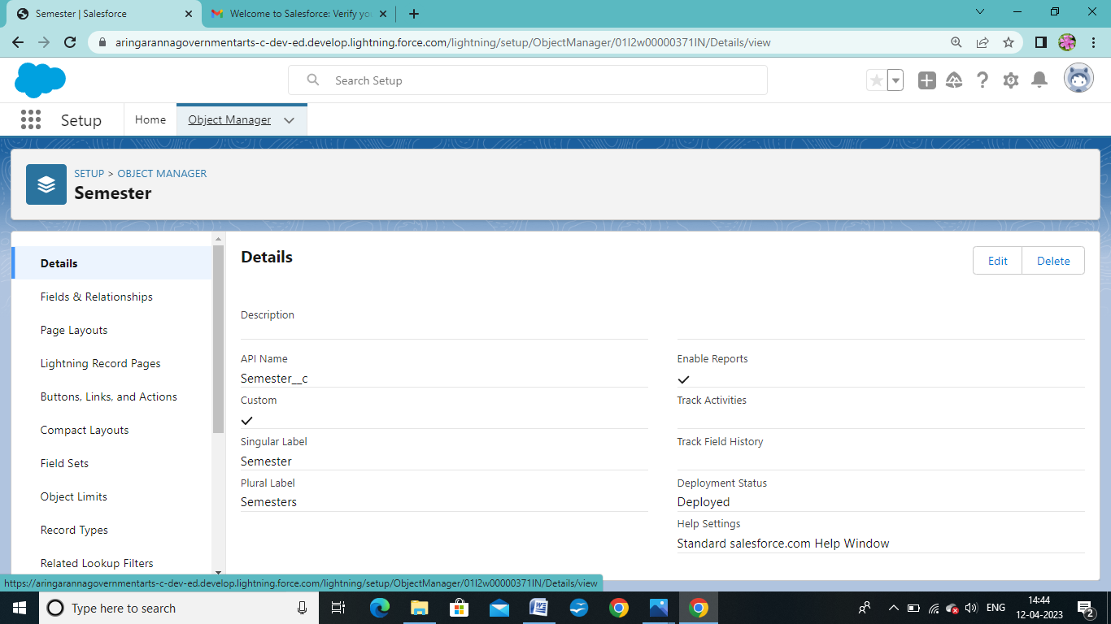

Activity 2: Candidate

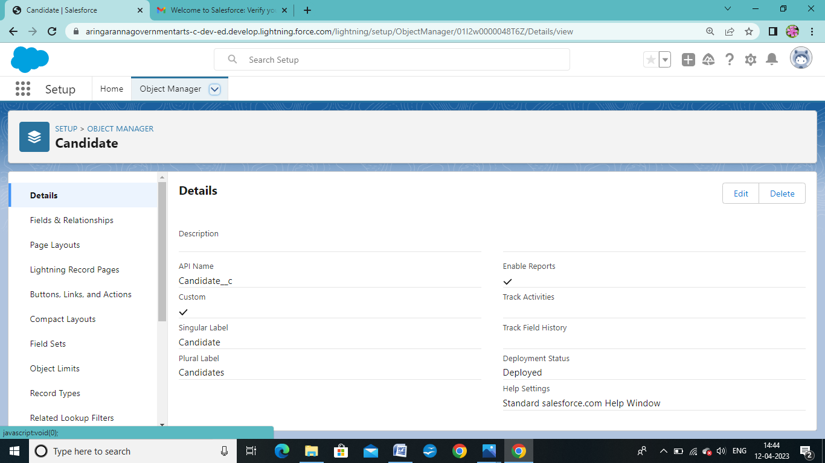

Lecture Details:

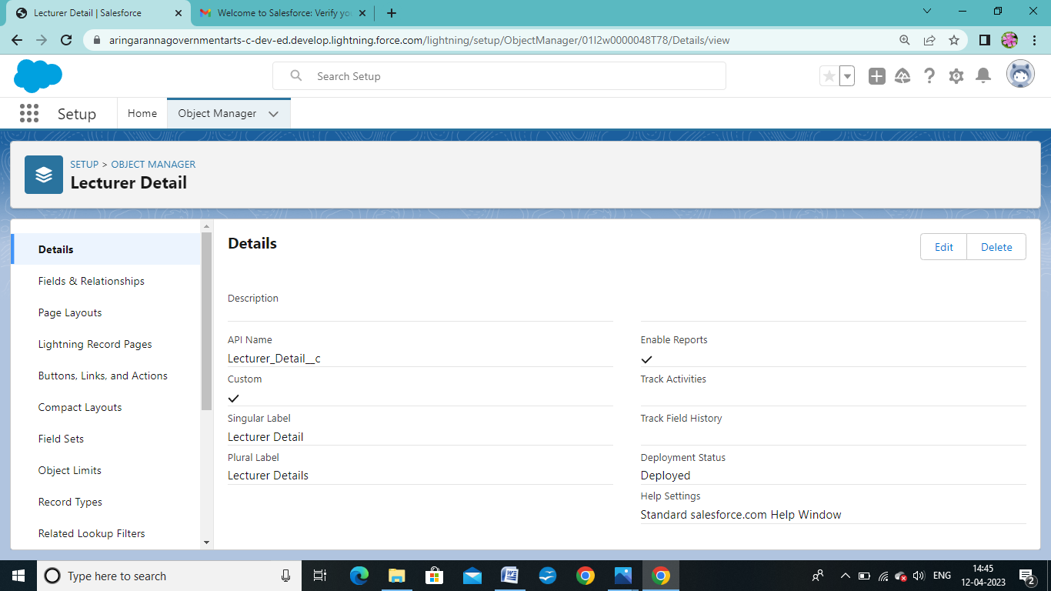

Course Details:

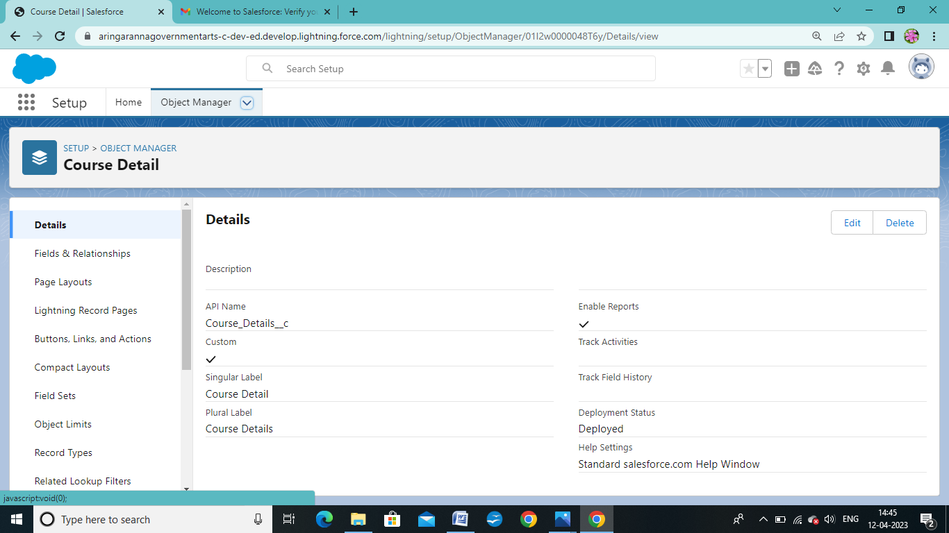

Internal Results:

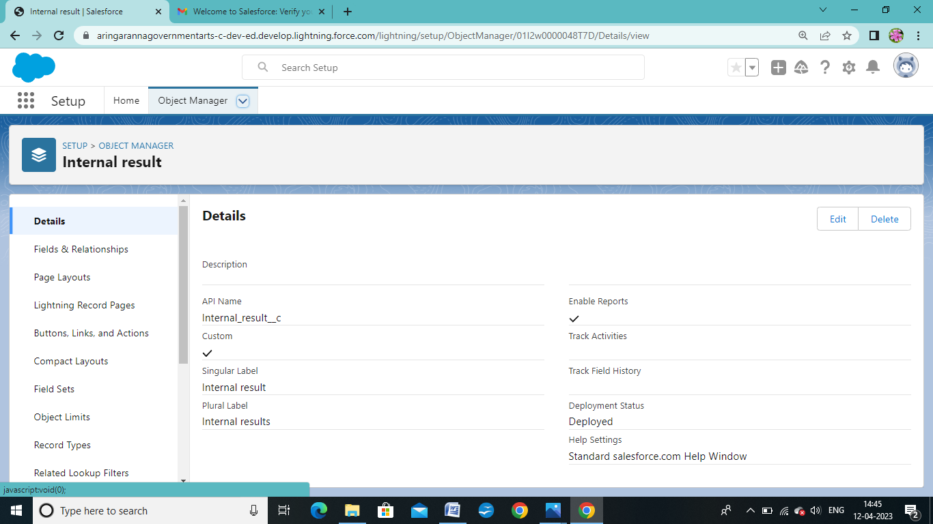

Milestone 2: Fields and Relationship

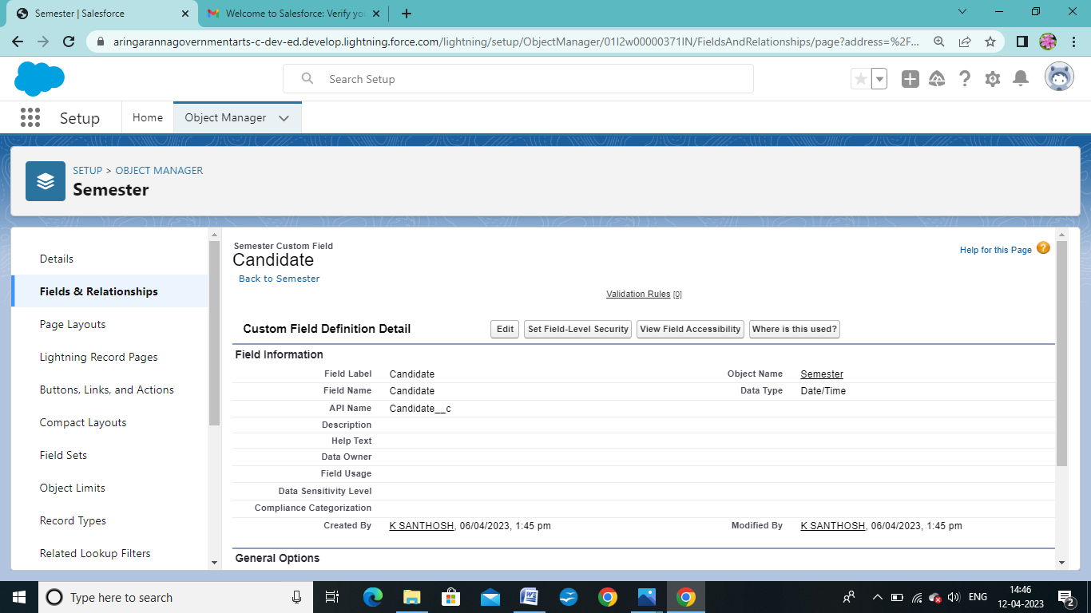

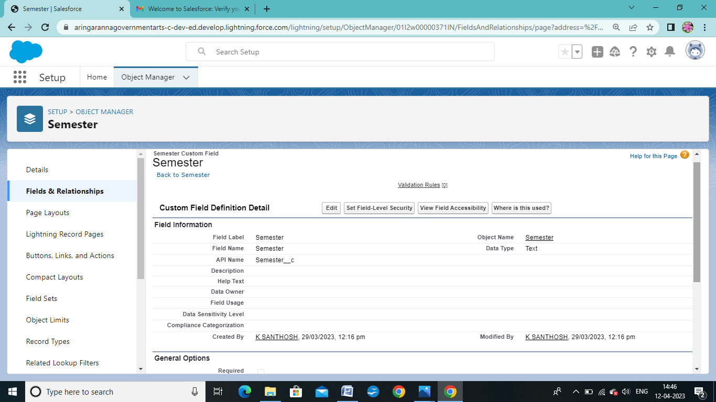

Milestone 3: Lightning App Activity :1

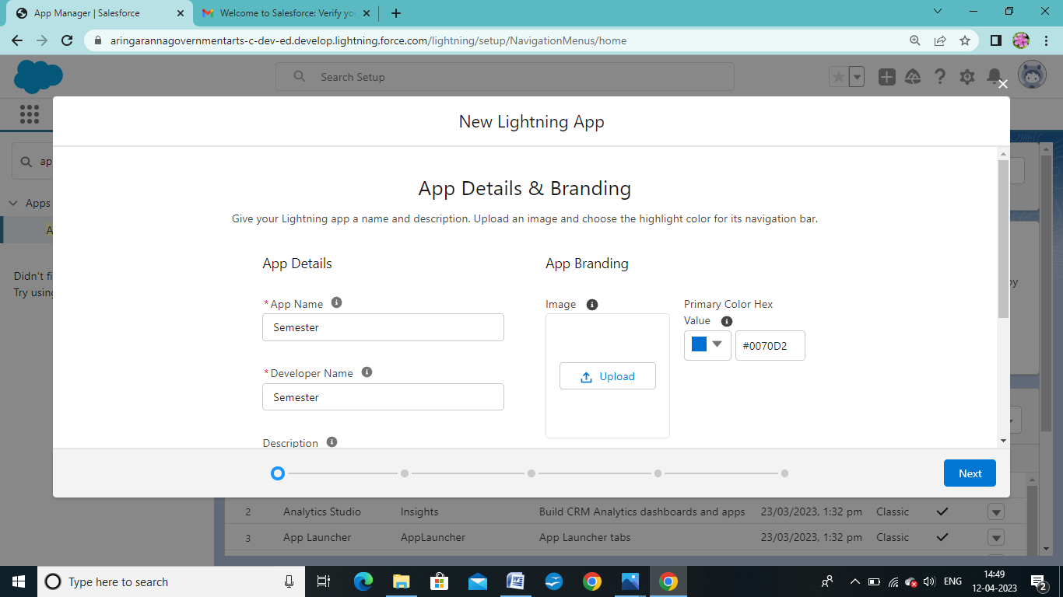

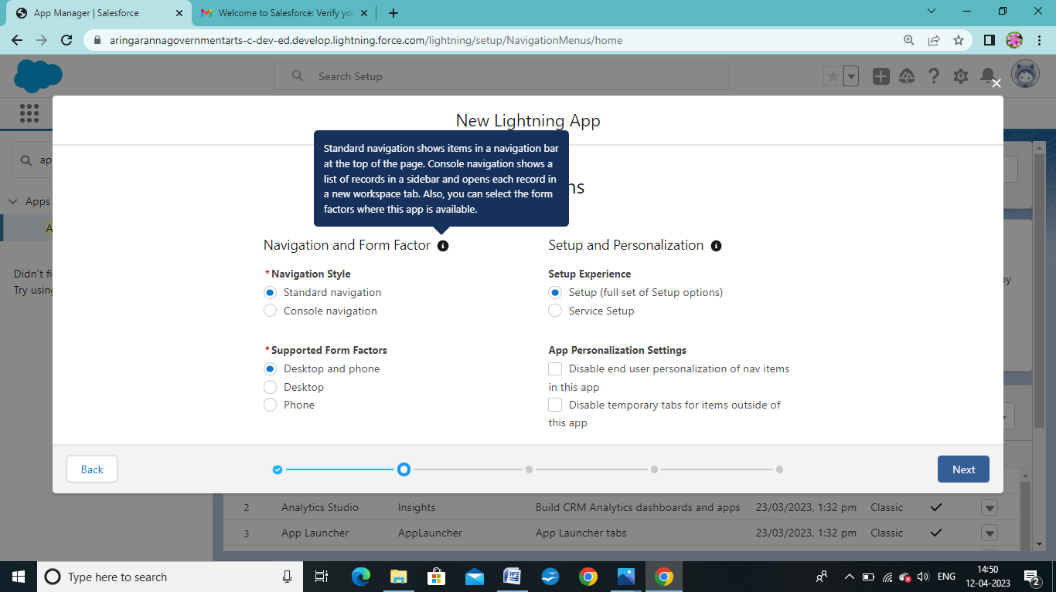

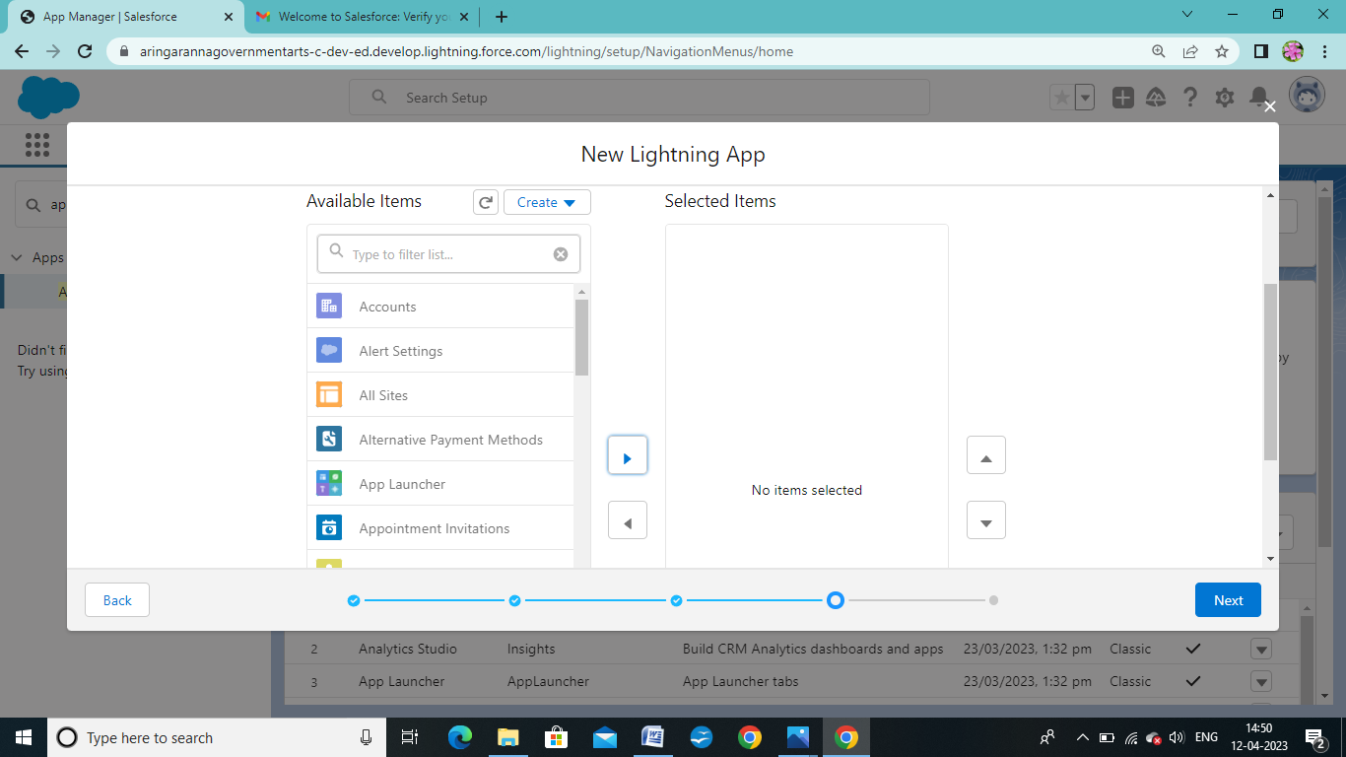

Milestone 4: Users Activity 1:

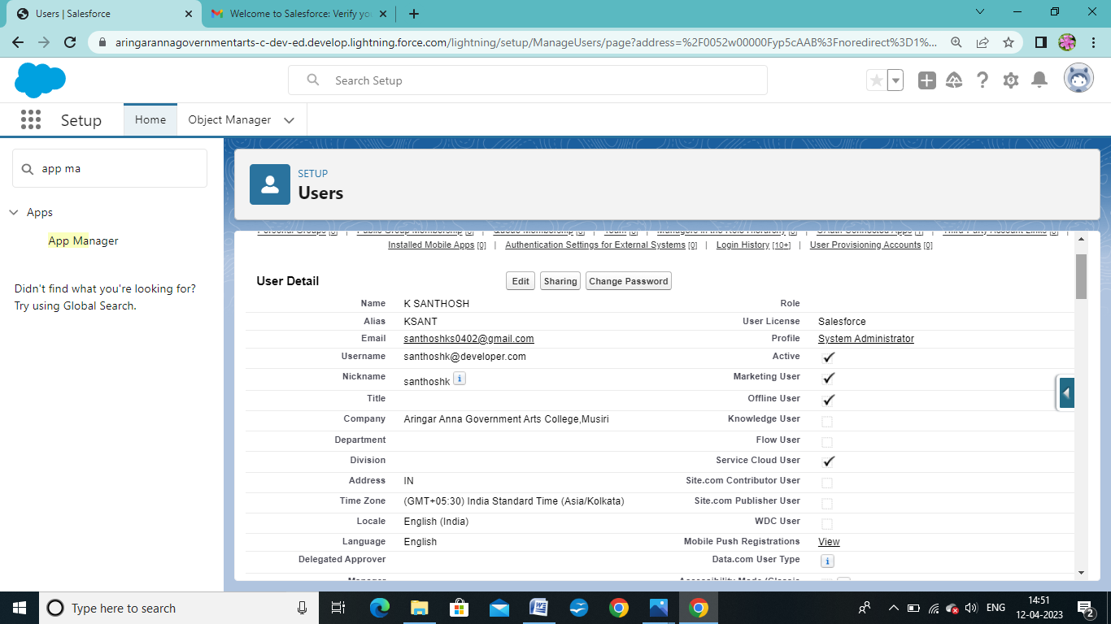

Milestone – 5 Reports

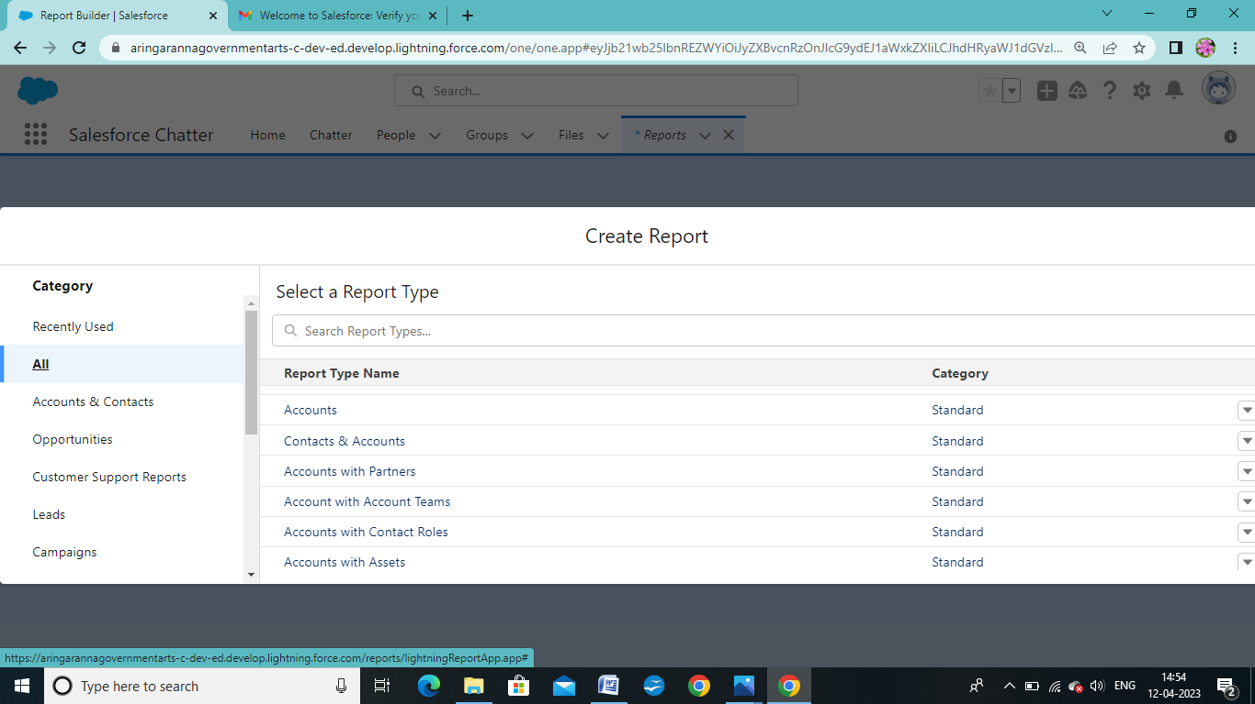

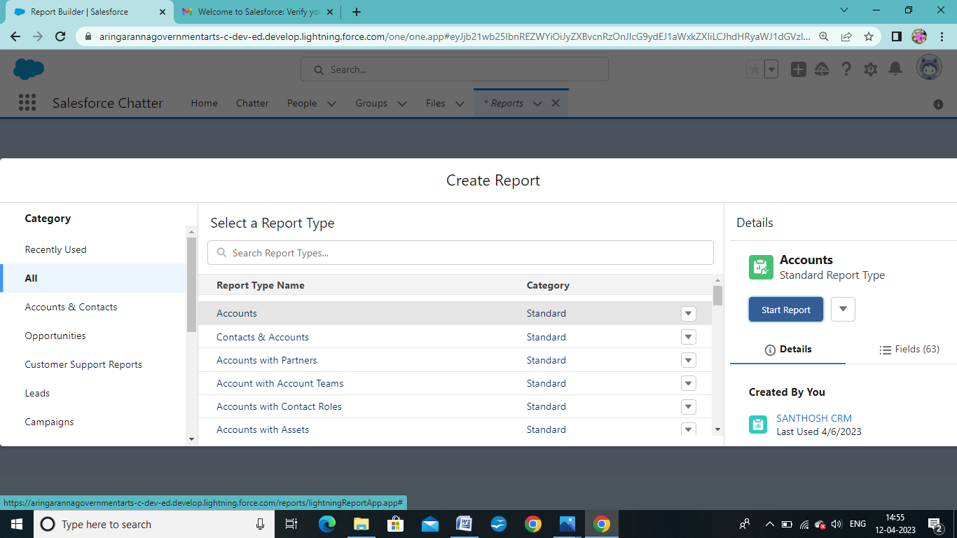

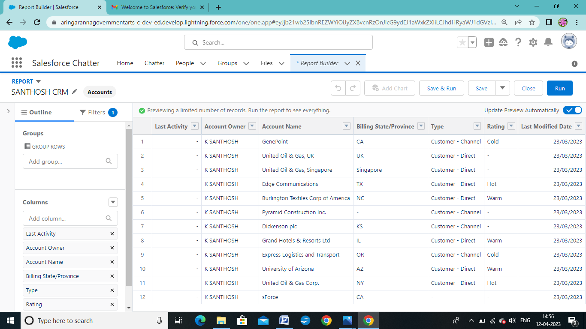

Milestone:6 Dashboards:

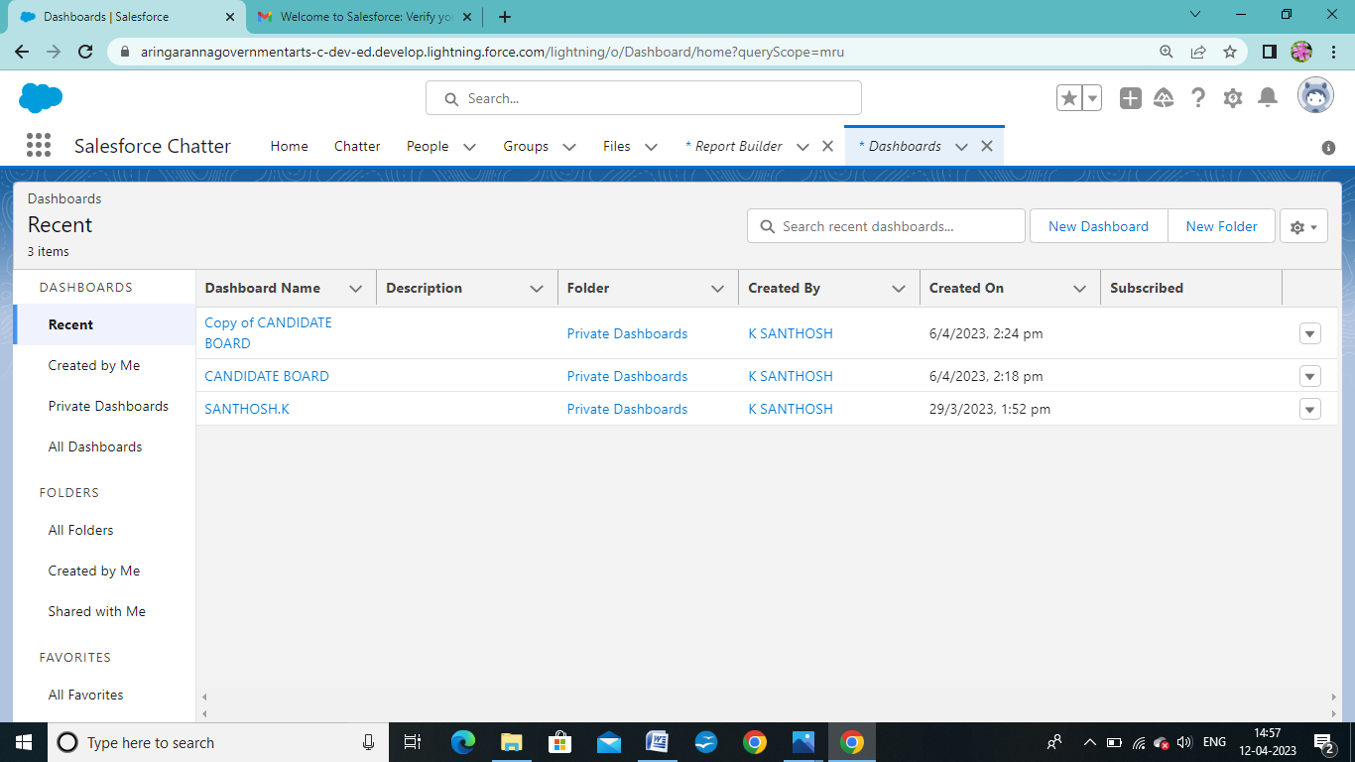

Trailhead Profile Public URL

Team Lead- <https://trailblazer.me/id/mathv7>

Team Member 1- <https://trailblazer.me/id/n20034>

Team Member 2- <https://trailblazer.me/id/santk45>

Team Member 3- <https://trailblazer.me/id/sath37>

PROJECT REPORT TEMPLATE

1. ADVANTAGES & DISADVANTAGE

The advantages of a business using a CRM system greatly outweigh the disadvantages. However, there are pitfalls. For a CRM system to work, there needs to be buy-in across the organisation and the processes in place to support it. Otherwise, your CRM may end up being an expensive waste of time. Here, we take a look at the strategic pros, cons, and importance of CRM.

|  |
| --- |
| **Pros** |
| * It allows for the consolidation of customer data and the basis for deep insights. * It speeds up the sales conversion process. * It increases staff productivity, lowering time-cost. * It allows geographically dispersed teams to collaborate effectively. * Improves customer experience by allowing personalisation and improved query resolution. |

1. APPLICATIONS

CRM's free edition can support up to 3 users and offers critical features that a business of that size needs. This includes leads, deals, and contact management, tasks and events, multichannel marketing, integrations to other Zoho apps, and more! For more information, check out the full feature list.

7. CONCLUSION

CRM in retail **allows businesses to make smarter decisions to better serve their customers and maximize profits from repeat purchases**. By implementing a CRM into your retail sales process, you can enhance customer relationships by providing personalized service that caters to their individual needs

8. FUTURE SCOPE

**Customers will become a company's best sales reps through superior products and services as well as customer-oriented messaging**. The future of CRM is more than just the future of Customer Relationship Management software. It is really the future of business.